MSP使用说明

进入期刊列表
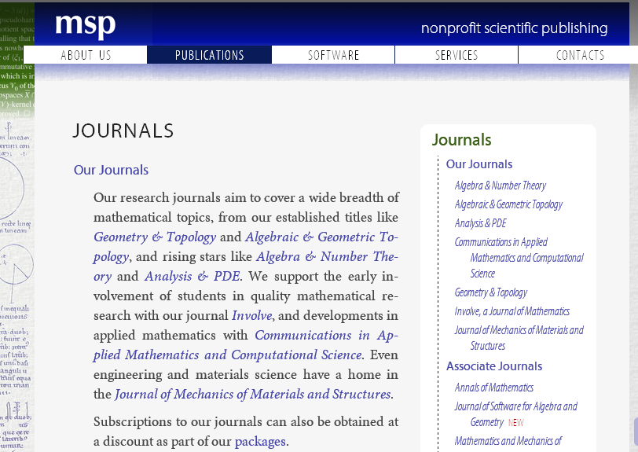
期刊的页面右列有所有期刊的列表，选择其中一种期刊，即可进入该期刊的详细说明
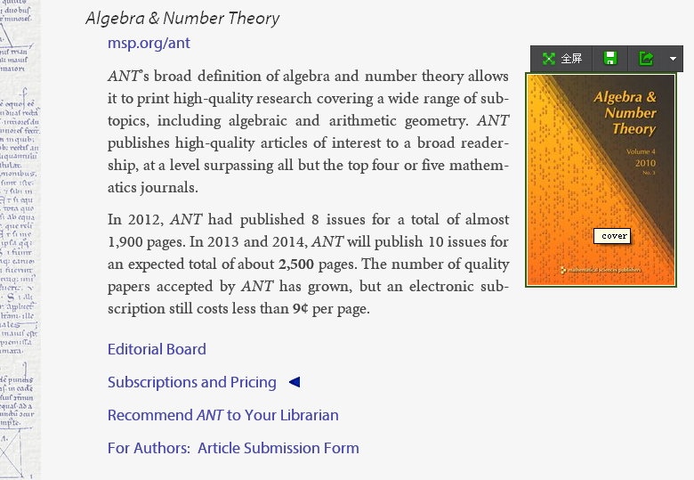
如图所示，进入期刊介绍后在期刊标题下面的链接即为期刊的链接，可直接点击进入，不同期刊链接不同

下面是MSP期刊的链接
期刊名 | 期刊链接
Algebra & Number Theory | msp.​org/​ant
Algebraic & Geometric Topology | msp.​warwick.​ac.​uk/​agt
Analysis & PDE | msp.​org/​apde
Comm. in Appl. Math. and Computational Science | msp.​org/​camcos
Geometry & Topology | msp.​warwick.​ac.​uk/​gt
Involve: A journal of mathematics | msp.​org/​involve
Journal of Mechanics of Materials and Structures | msp.​org/​jomms
Annals of Mathematics | annals.​math.​princeton.​Edu
Pacific Journal of Mathematics | msp.​org/​pjm
Mathematics and Mechanics of Complex Systems | msp.​org/​memocs
Journal of Software for Algebra and Geometry | msp.​org/​jsag
Annals of K-Theory http://msp.org/akt/about/cover/cover.html | msp.org/akt
选择Algebra & Number Theory的链接msp.​org/​ant点击进入期刊页面，如下图所示
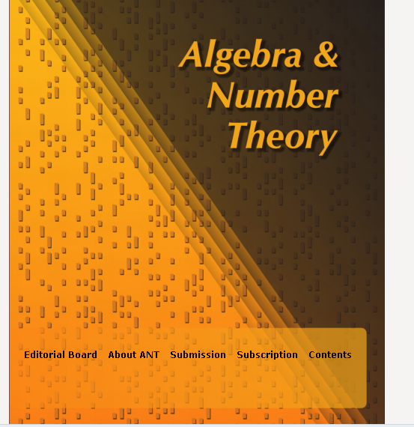
期刊介绍
编辑信息
期刊的具体内容信息，点击Content,如下图所示
最近一期期刊内容
所有往期期刊，点击进入，如下图所示

左上角显示下载信息（点击FOR SCREEN 可以浏览期刊，点击FOR PRINTING直接下载期刊文章。）
左下角显示所有往期期刊信息，可点击选择
右边为选择的每期期刊的具体文章内容。如果查看文章可点击文章标题进入。

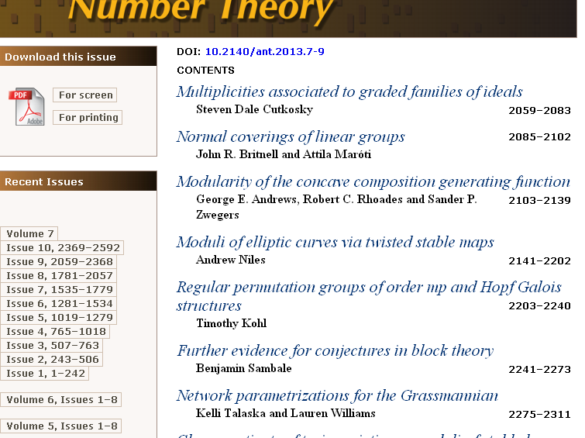

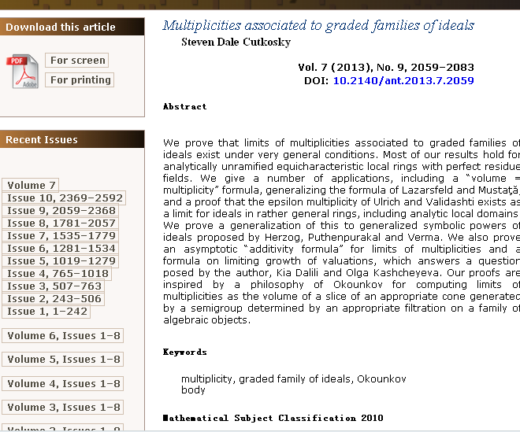
作者信息
关键词
文章概要
左上角显示下载信息（点击For Screen 可以浏览期刊，点击For Printing直接下载期刊文章。）

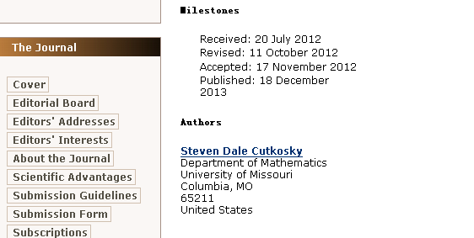
该期刊的相关信息

